EXP 1: TESTING
- Cấu hình tham số huấn luyện chung:
Tỷ lệ chia = 70/15/15
Epochs = 100
Batch size = 16
Image size = 640 × 640
Optimizer = AdamW
lr₀ = 0.001
lrf = 0.01
Momentum = 0.937
Weight decay = 0.0005
Warmup epochs = 2.0
Warmup momentum = 0.8
Warmup bias LR = 0.1
cos_lr = false
Seed = 42
IoU threshold = 0.7
Max detections = 300

- Augmentation: Mosaic, Flip LR, HSV Hue Jitter, HSV Saturation Jitter, HSV Value Jitter, Scale, Translate, Random Erasing, RandAugment.
-----------------
- Kết quả: Baseline vs CBAM@BackBone vs CBAM@Neck vs CBAM@Head vs CBAM@Neck + Head vs CBAM@BackBone + Head (Best Epoch )
Models | Precision | Recall | F1-score | mAP@0.5 | mAP@0.5:0.95 | GFLOPs | FPS
YOLOV11n | 0.6965 | 0.5880 | 0.6377 | 0.6349 | 0.3886 | 6.5 | 68.5
YOLOV11n + CBAM@BackBone | 0.5198 | 0.6136 | 0.5628 | 0.5971 | 0.3392 | 6.6 | 64.2
YOLOV11n + CBAM@Neck | 0.7108 | 0.5765 | 0.6366 | 0.6324 | 0.3821 | 6.6 | 65.0
YOLOV11n + CBAM@Head | 0.6801 | 0.5805 | 0.6264 | 0.6264 | 0.3692 | 6.6 | 64.8
YOLOV11n + CBAM@Neck + Head | 0.6412 | 0.6455 | 0.6433 | 0.6706 | 0.3952 | 6.7 | 62.1
YOLOV11n + CBAM@BackBone + Head | 0.5719 | 0.6284 | 0.5988 | 0.6258 | 0.3915 | 6.6 | 63.8

- Kết quả: Theo từng loại class (Best Epoch)

Class | Support | Baseline | +CBAM@Backbone | +CBAM@Neck | +CBAM@Head | +CBAM@Neck+Head
bent | 11 | 0.5292 | 0.6509 | 0.5359 | 0.6464 | 0.6709
bent_lead | 3 | 0.6941 | 0.7100 | 0.4743 | 0.4670 | 0.9950
bent_wire | 2 | 0.3308 | 0.3079 | 0.5950 | 0.8283 | 0.9950
broken | 6 | 0.4536 | 0.4284 | 0.6475 | 0.5457 | 0.2486
broken_large | 2 | 0.8283 | 0.6633 | 0.6633 | 0.6633 | 0.8283
broken_small | 4 | 0.8283 | 0.5902 | 0.7706 | 0.7744 | 0.7658
broken_teeth | 5 | 0.5435 | 0.4761 | 0.5496 | 0.5275 | 0.5950
cable_swap | 2 | 0.1238 | 0.0619 | 0.2475 | 0.2475 | 0.4950
color | 24 | 0.5163 | 0.4785 | 0.5573 | 0.5090 | 0.5819
combined | 27 | 0.2004 | 0.2435 | 0.1713 | 0.2515 | 0.1458
contamination | 5 | 0.3412 | 0.4950 | 0.3818 | 0.4014 | 0.4082
crack | 22 | 0.2472 | 0.3148 | 0.2456 | 0.2683 | 0.3079
cut | 8 | 0.6238 | 0.5842 | 0.7440 | 0.7336 | 0.5741
cut_inner_insulation | 4 | 0.6825 | 0.4550 | 0.6021 | 0.6200 | 0.4470
cut_lead | 2 | 0.9950 | 0.9950 | 0.9950 | 0.9950 | 0.9950
cut_outer_insulation | 2 | 0.0000 | 0.0000 | 0.0000 | 0.0000 | 0.4950
damaged_case | 2 | 0.9950 | 0.6617 | 0.9950 | 0.9950 | 0.9950
defective | 9 | 0.5016 | 0.1444 | 0.5394 | 0.4933 | 0.4313
fabric_border | 3 | 0.9950 | 0.9125 | 0.8300 | 0.7530 | 0.9125
fabric_interior | 2 | 0.5262 | 0.9950 | 0.6633 | 0.5062 | 0.9950
faulty_imprint | 6 | 0.8050 | 0.3883 | 0.5519 | 0.6069 | 0.7334
flip | 3 | 0.9950 | 0.9950 | 0.9950 | 0.9950 | 0.9950
fold | 2 | 0.4950 | 0.5950 | 0.2719 | 0.6617 | 0.7450
glue | 5 | 0.8206 | 0.7649 | 0.8114 | 0.7725 | 0.8142
glue_strip | 3 | 0.9950 | 0.9950 | 0.9950 | 0.9950 | 0.9950
gray_stroke | 2 | 0.9950 | 0.9950 | 0.9950 | 0.9950 | 0.9950
hole | 11 | 0.8083 | 0.8084 | 0.7813 | 0.8191 | 0.6724
liquid | 4 | 0.7450 | 0.7450 | 0.8219 | 0.7450 | 0.7450
manipulated_front | 3 | 0.0464 | 0.0929 | 0.0682 | 0.0294 | 0.0245
metal_contamination | 7 | 0.6338 | 0.5941 | 0.6642 | 0.7047 | 0.7109
misplaced | 2 | 0.9950 | 0.9950 | 0.9950 | 0.9950 | 0.9950
missing_cable | 2 | 0.9950 | 0.9950 | 0.9950 | 0.9950 | 0.9950
missing_wire | 2 | 0.8283 | 0.6633 | 0.9950 | 0.7450 | 0.7450
oil | 3 | 0.9950 | 0.9950 | 0.9950 | 0.9950 | 0.9950
pill_type | 1 | 0.9950 | 0.9950 | 0.9950 | 0.9950 | 0.9950
poke | 6 | 0.3045 | 0.2951 | 0.4512 | 0.2249 | 0.4286
poke_insulation | 3 | 0.4150 | 0.7640 | 0.3317 | 0.7888 | 0.5450
print | 2 | 0.9950 | 0.9950 | 0.9950 | 0.8283 | 0.9950
rough | 6 | 0.9950 | 0.9950 | 0.9950 | 0.9950 | 0.9950
scratch | 23 | 0.4663 | 0.5551 | 0.5112 | 0.6107 | 0.5414
scratch_head | 3 | 0.5869 | 0.2800 | 0.8630 | 0.9950 | 0.5990
scratch_neck | 7 | 0.3434 | 0.4574 | 0.4687 | 0.3580 | 0.3423
split_teeth | 3 | 0.6413 | 0.4975 | 0.4975 | 0.7463 | 0.7530
squeeze | 3 | 0.3350 | 0.1675 | 0.0690 | 0.0010 | 0.3350
squeezed_teeth | 2 | 0.6379 | 0.7450 | 0.5950 | 0.3244 | 0.6379
thread | 10 | 0.3067 | 0.2093 | 0.2783 | 0.2194 | 0.3051
thread_side | 4 | 0.2845 | 0.0030 | 0.0522 | 0.0692 | 0.3164
thread_top | 3 | 0.3350 | 0.4083 | 0.3385 | 0.3482 | 0.3350

- Learning Curve
- Baseline
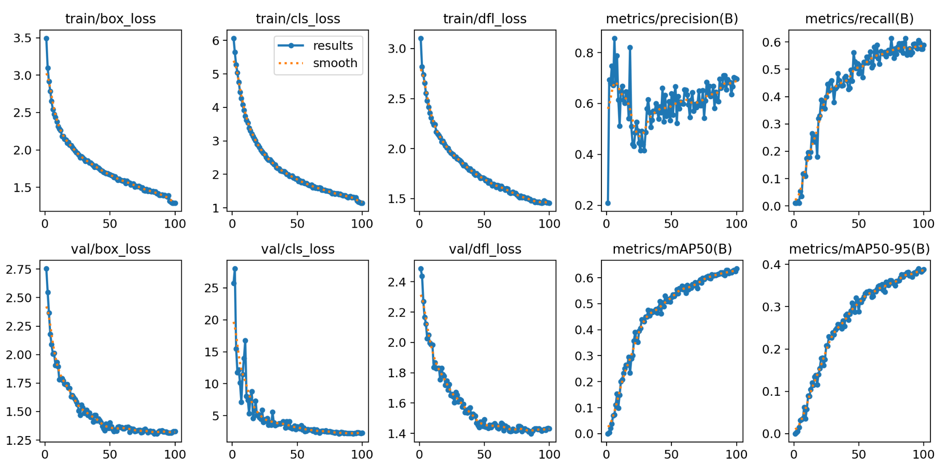

- CBAM@BackBone
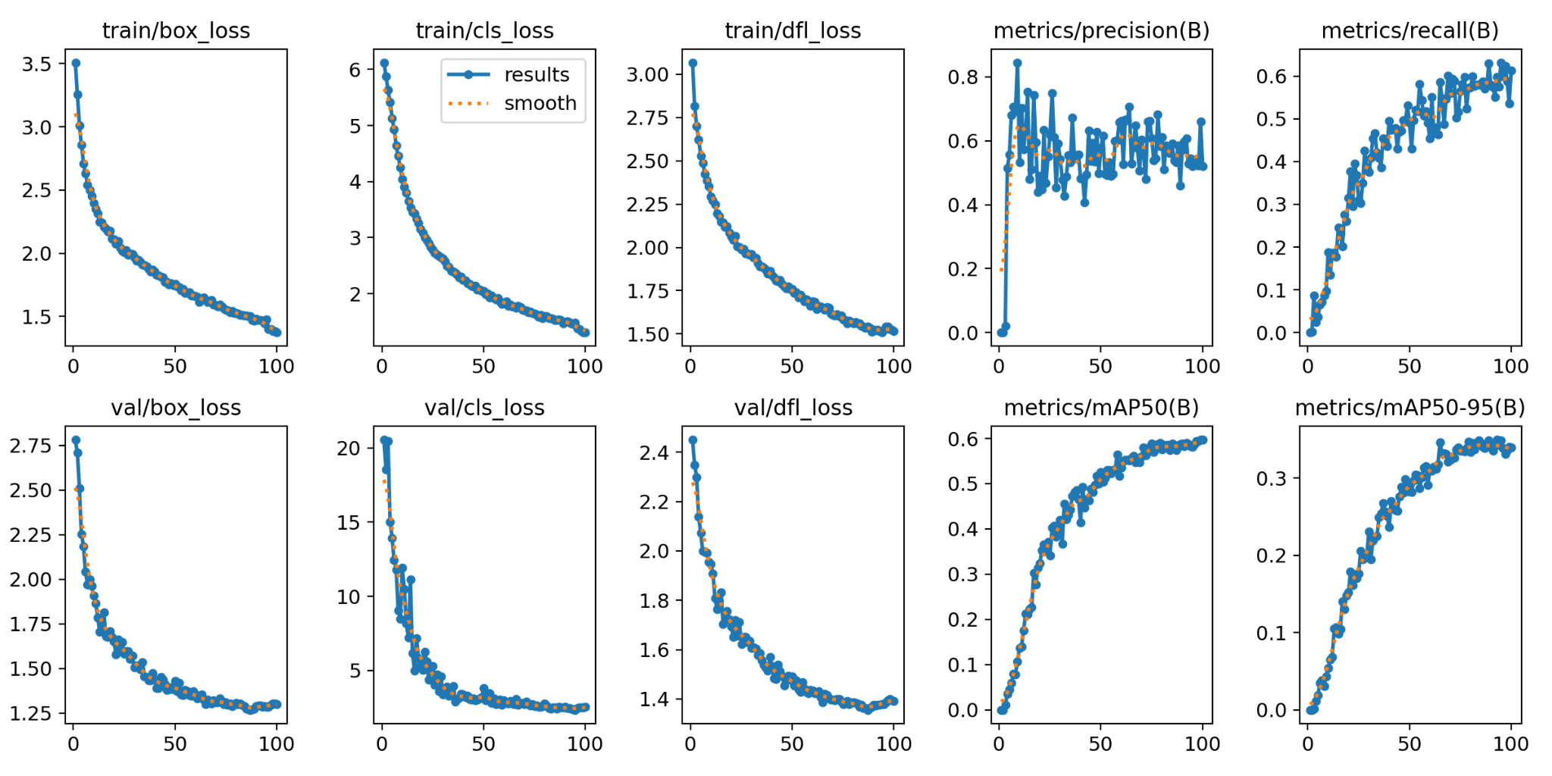
- CBAM@Neck
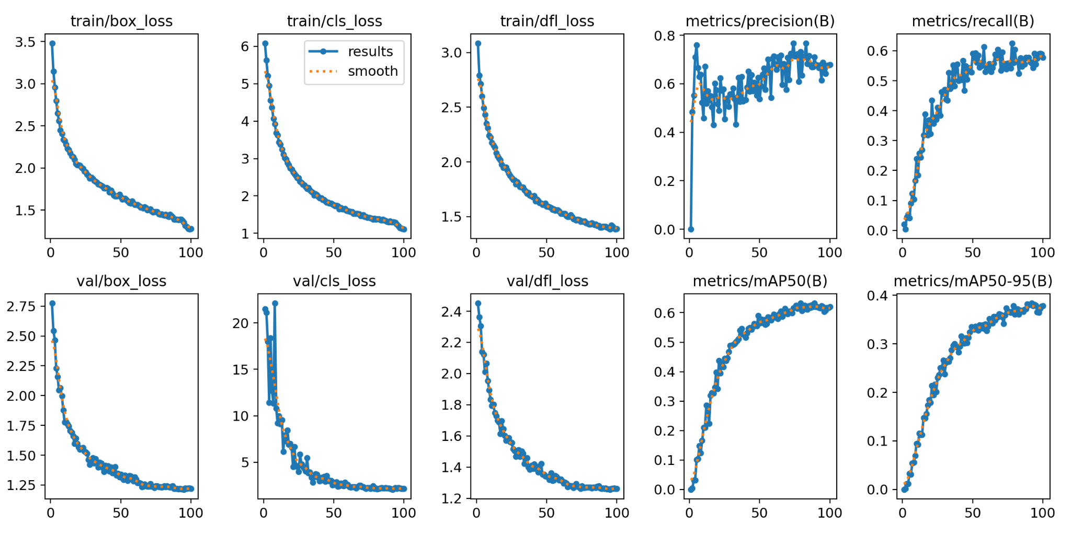

- CBAM@Head
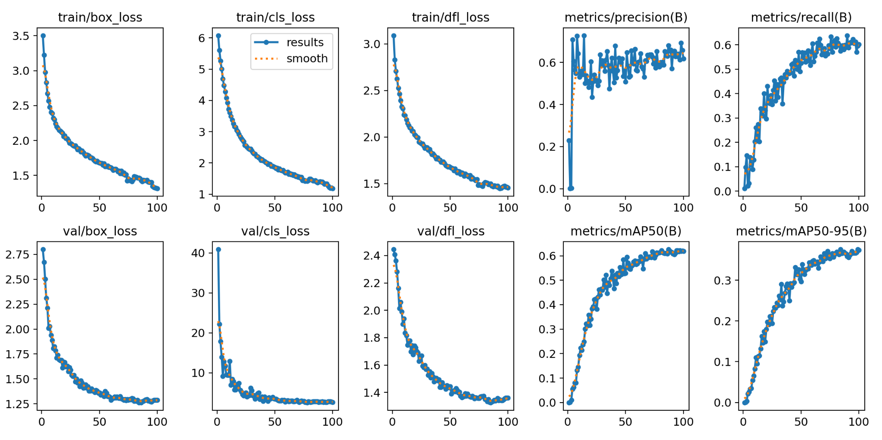
- CBAM@Neck + Head

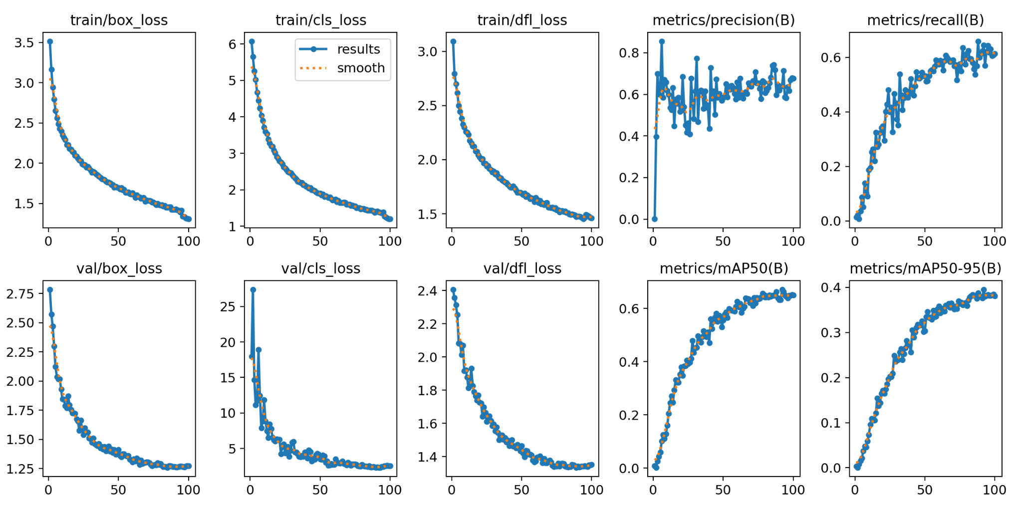

CBAM@BackBone + Head
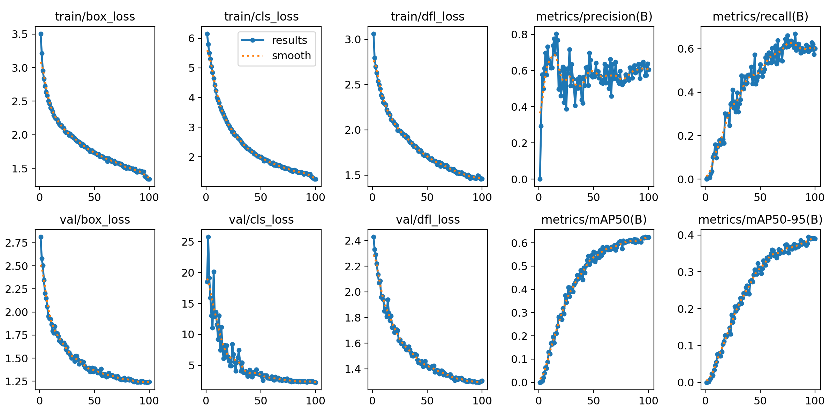

- Learning Curves Comparison
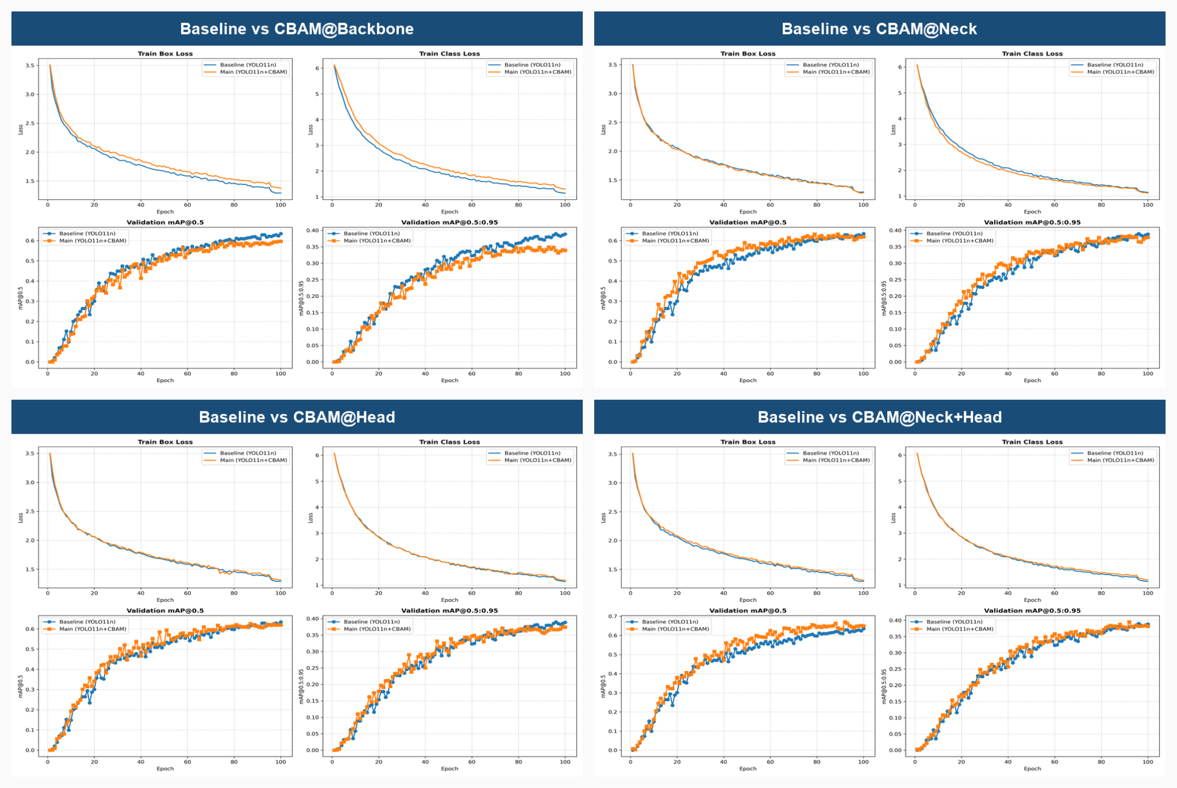

- Normalized Confusion Matrix
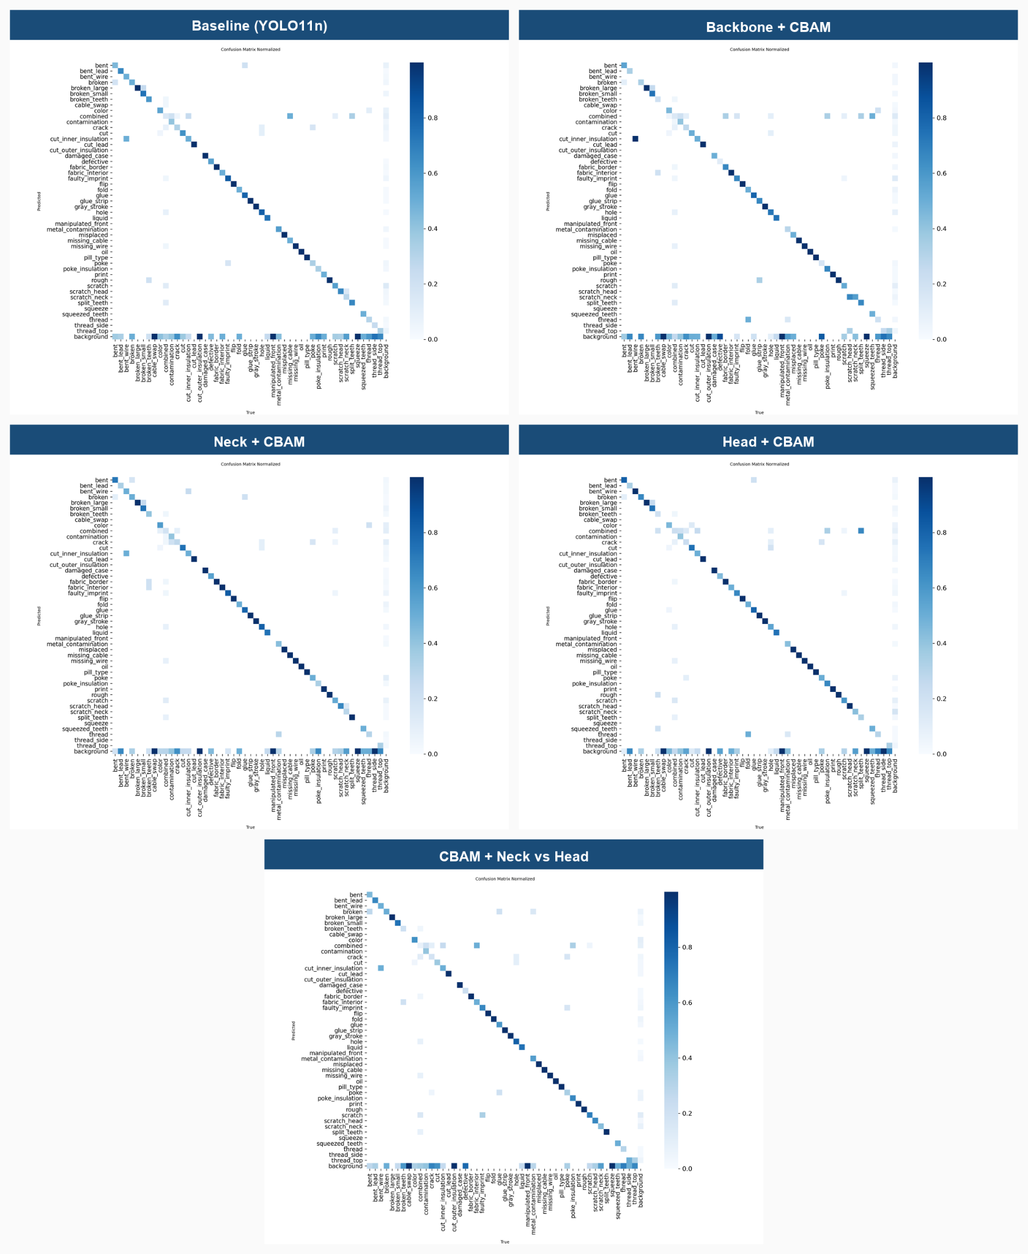

- Confusion Matrix
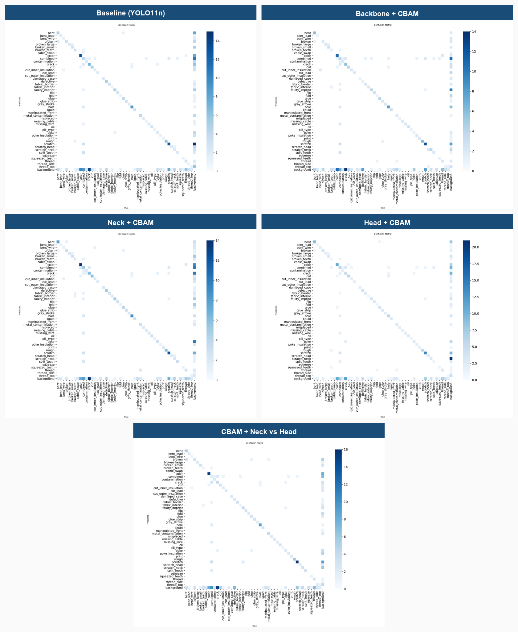

- PR Curve
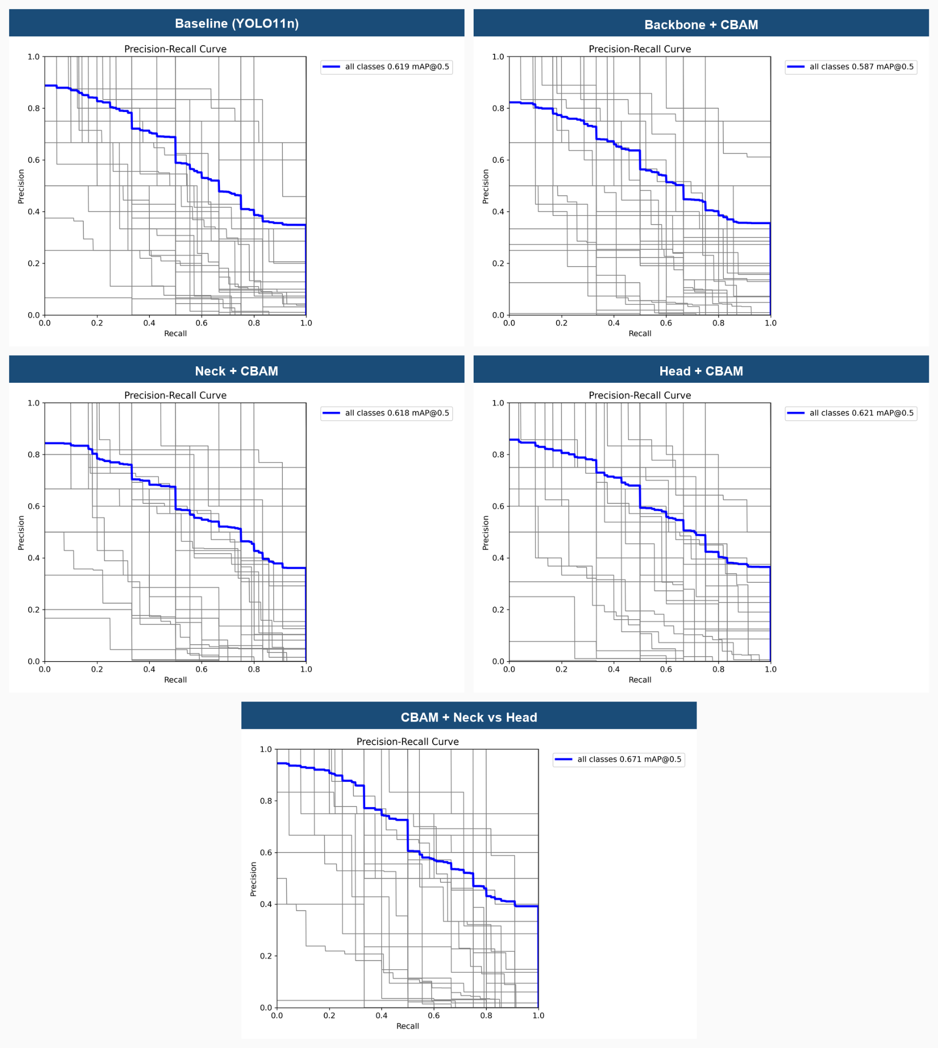

- F1-Confidence Curve
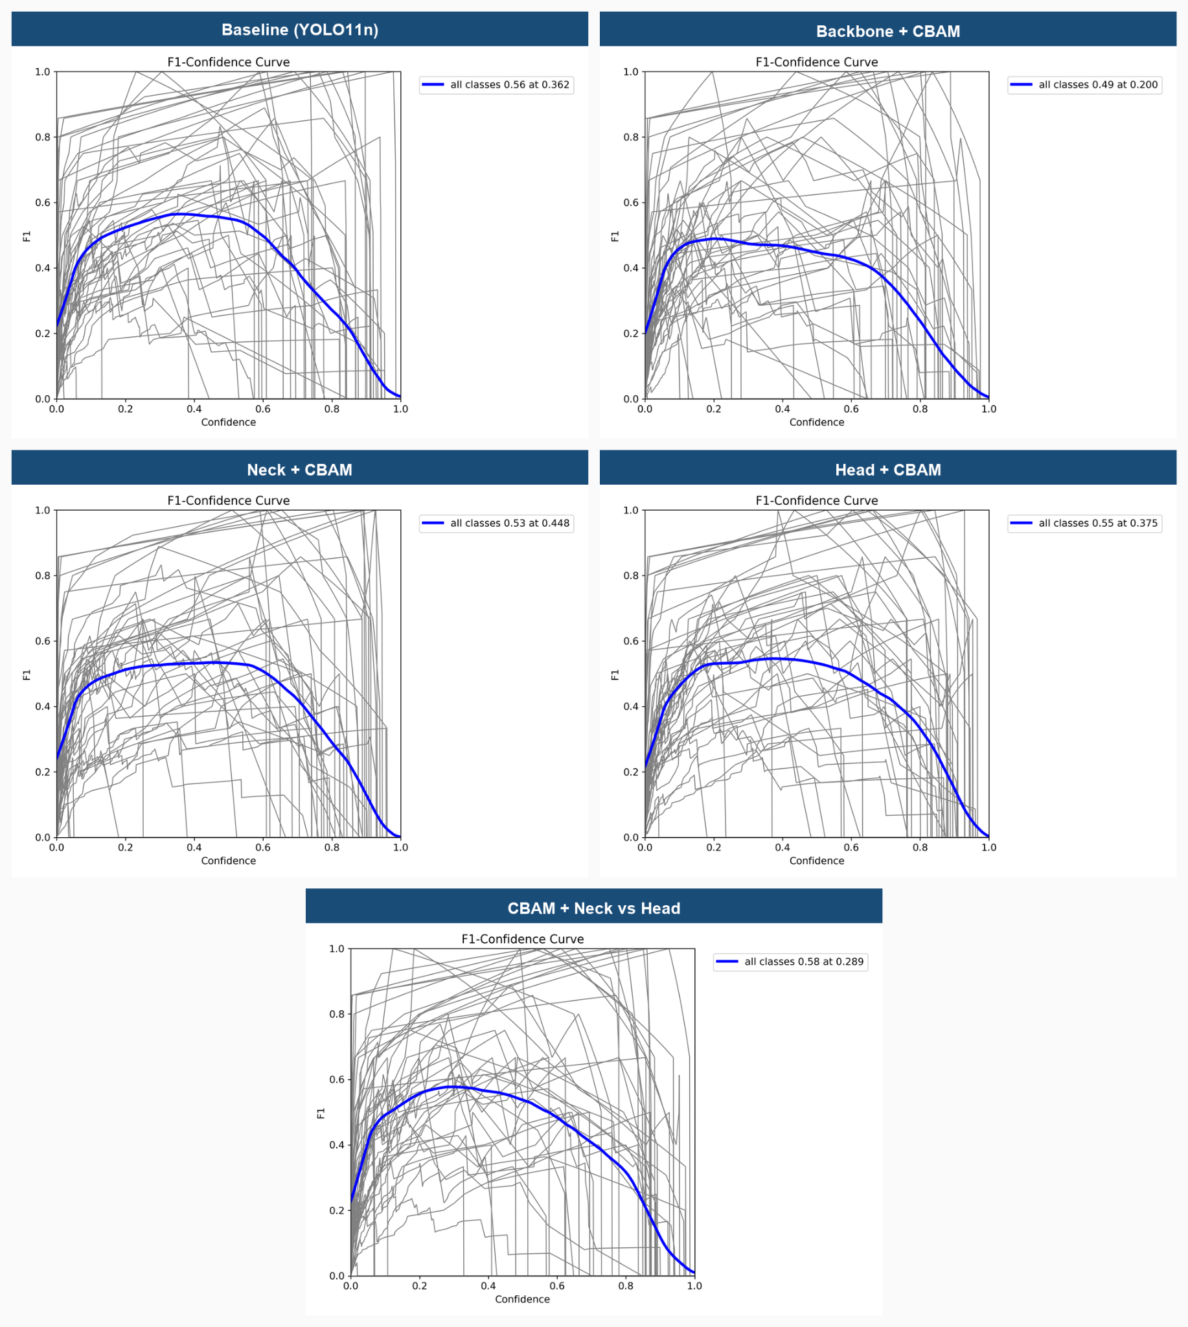

- Precision-Confidence Curve
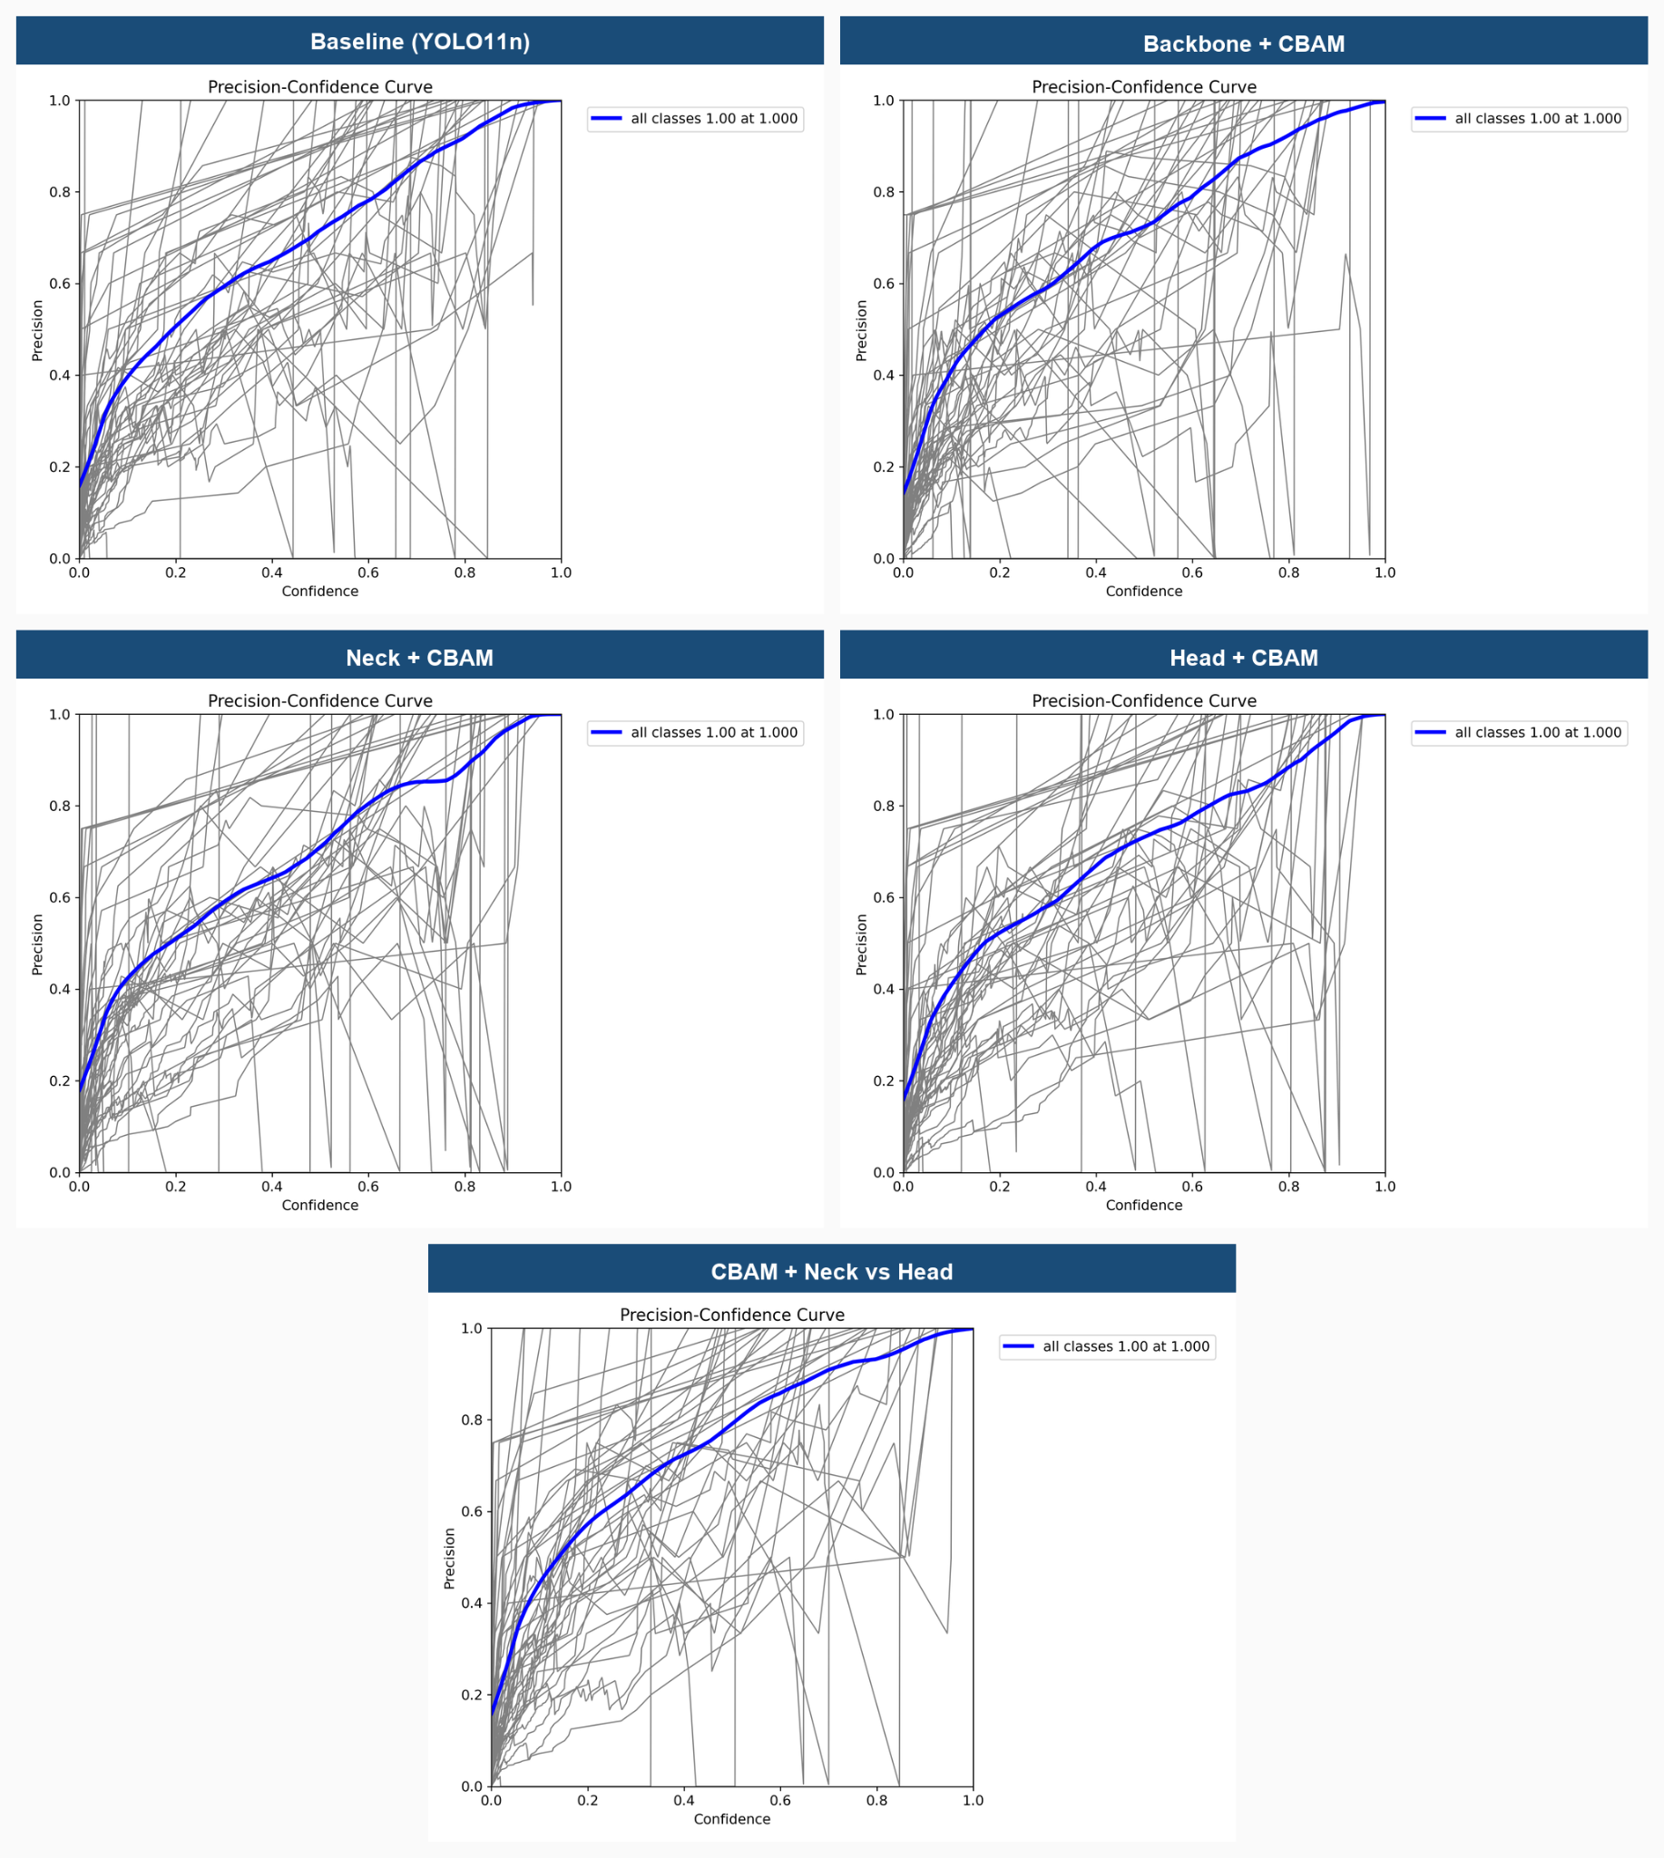

- Recall-Confidence Curve
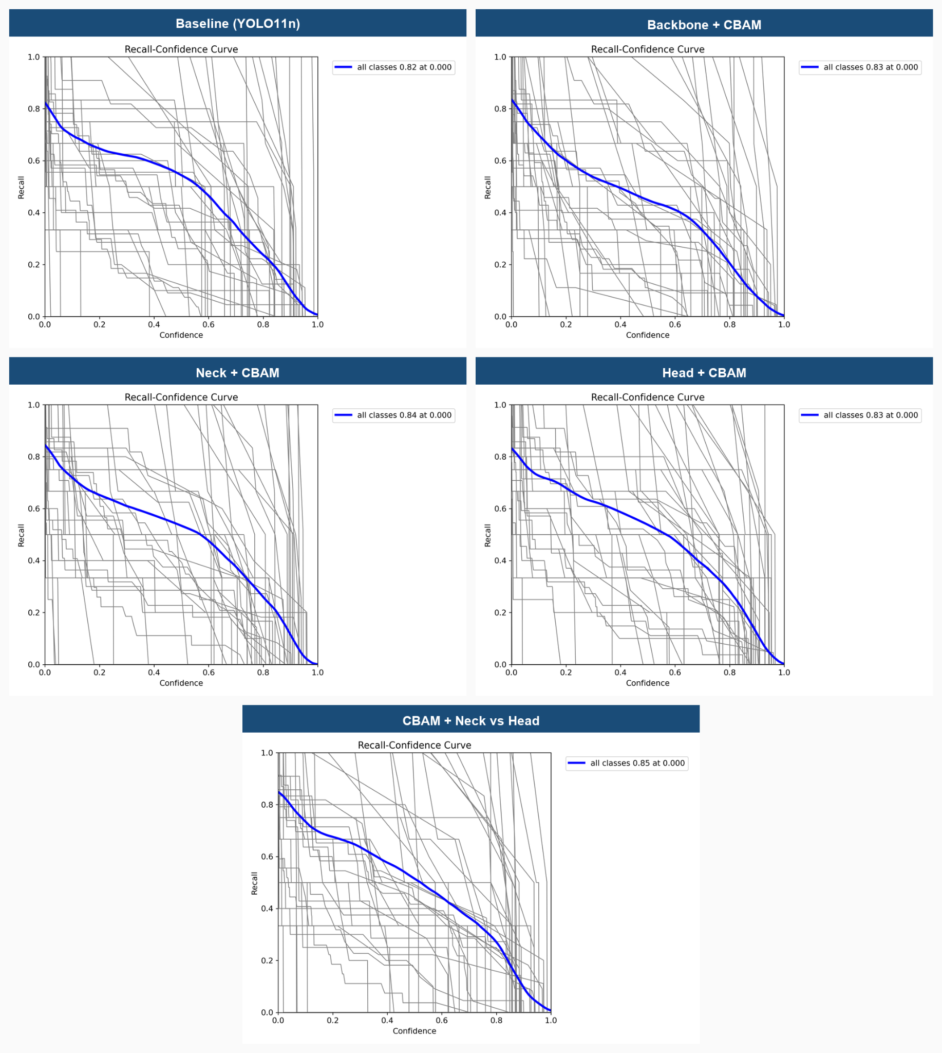

- Biểu đồ so sánh các chỉ số tổng thể
